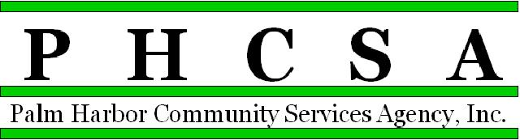
Board Meeting Agenda - 7:00 PM February 16, 2022
Meeting Location: Palm Harbor Library

1. Opening by Phil Phillips, Chair Call to Order; Roll Call, Pledge

2. Meeting Notice Confirmation

3. Approval of Minutes – January Exhibit

4. Public Comment/Presentations

5. Treasurer’s Report – Phil Wagner

6. Agency Items
a. Old Business
a. PHCSA Retreat Update and report
b. New Business
a. Officer Positions – Election - Confirmation
Chair: Phil Phillips
Vice-Chair: Open
Treasurer: Phil Wagner
Secretary: Scott Papes
b. Mid-year Retreat – Schedule
c. Additional evaluation updates from Advisory Boards, throughout the year
d. Salary Range updates – confirm process to update Ranges
e. Bonus discussion
f.

7. East Lake Community Library
a. Monthly Financial for January - Approval Exhibit
b. Director’s Report - Approval Exhibit
c. Old Business:
d. New Business:

8. Palm Harbor Library
a. Monthly Financial for January - Approval Exhibit
b. Director’s Report - Approval Exhibit
c. Old Business:
d. New Business: Upgrade Martin Conference Room

9. East Lake Recreation
- Monthly Financial for January - Approval Exhibit
- Director’s Report - Approval Exhibit
- Old Business:
- New Business:

10. CSA Palm Harbor Parks and Recreation
a. Monthly Financial for January - Approval Exhibit
b. Director’s Reports - Approval Exhibit
c. Old Business:
d. New Business:

11. Designation of Next Meeting: March 16, 2022, 7:00 p.m., at CSA Palm Harbor

12. Adjournment

