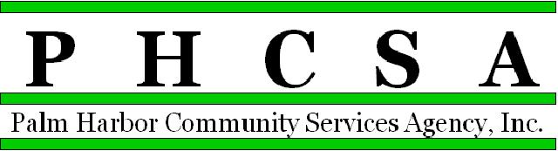

Board Meeting Agenda - 6:00 PM June 15, 2022
Meeting Location: Palm Harbor Community Library

1. Opening by Phil Phillips, Chair Call to Order; Roll Call, Pledge

2. Meeting Notice Confirmation

3. Approval of Minutes – April (no meeting in May) Exhibit

4. Public Comment/Presentations
Welcome to Palm Harbor Library representatives – Introductions – Gene Coppola

5. Treasurer’s Report – Phil Wagner
Cadence Bank Representative

6. Agency Items

a. Old Business
a. ARPA Funding Opportunities and how should PHCSA entities apply for them. This is the American Rescue Plan Act – intended to stimulate economy and off set the negative effects of COVID – Pinellas County received $$$ and they have set aside 10% for unincorporated Pinellas County – approximately $19,000,000.00 – all other funds have been earmarked for County Projects – Projects must be committed by September of 2024 with finished by December of 2026. County wants funding to be administered by a third party. (This is similar to MSTU funding projects – one and done, not ongoing expenses) Project categories will be submitted for review and comments.

b. New Business
a. Confirm June 25th PHCSA Summer planning retreat – location and time.
Agenda items to be addressed – Please submit to Deborah Griswold

c. Committee reports
a. Managing Director Research Committee
b. Marketing Committee
c. By-Laws update

d. Agenda items – how are they included
e. Process for changing meeting time and date
f. How many excused absences are allowed per by-laws
g. PHCSA HR position – job description
h. MSTU funding - project applications – suggested that all projects being submitted under or by a PHCSA entity or for PHCSA properties be submitted for approval by PHCSA prior to submission to the County. No official procedure exists regarding submissions by entities.

7. CSA Palm Harbor Parks and Recreation
a. Monthly Financial for April and May – Approval required Exhibit
b. Director’s Report – Approval required Exhibit
c. Old Business:
d. New Business:

8. East Lake Community Library
a. Monthly Financial for April and May – Approval required Exhibit
b. Director’s Report – Approval required Exhibit
c. Old Business:
d. New Business:

9. Palm Harbor Community Library
- Monthly Financial for April and May – Approval required Exhibit
- Director’s Report – Approval required Exhibit
- Old Business:
- New Business:

10. East Lake Recreation
a. Monthly Financial for April and May – Approval required Exhibit
b. Director’s Reports – Approval required Exhibit
c. Old Business:
d. New Business:

11. Designation of Next Meeting: July 20, 2022, 6:00 p.m., at East Lake Library

12. Adjournment

