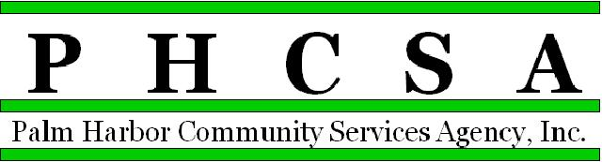
Board Meeting Agenda - 7:00 PM March 16, 2022
Meeting Location: CSA Palm Harbor

1. Opening by Phil Phillips, Chair Call to Order; Roll Call, Pledge

2. Meeting Notice Confirmation

3. Approval of Minutes – February Exhibit

4. Public Comment/Presentations

5. Treasurer’s Report – Phil Wagner
a. Financial Statements and Audit Report Exhibit
b. Audit Results Exhibit

6. Agency Items
a. Old Business
a.
b. New Business
a. State Worker salary increases and how it may affect our budgets
c. Committee reports
a. Managing Director Research Committee
b. Marketing Committee

7. Palm Harbor Library
a. Monthly Financial for February - Approval Exhibit
b. Director’s Report - Approval Exhibit
c. Old Business:
d. New Business:

8. East Lake Recreation
a. Monthly Financial for February - Approval Exhibit
b. Director’s Report - Approval Exhibit
c. Old Business:
d. New Business:

9. CSA Palm Harbor Parks and Recreation
- Monthly Financial for February - Approval Exhibit
- Director’s Report - Approval Exhibit
- Old Business:
- New Business:
  - Pre-Engineered Metal Building Project funds approval Exhibit

10. East Lake Community Library
a. Monthly Financial for February - Approval Exhibit
b. Director’s Reports - Approval Exhibit
c. Old Business:
d. New Business:
a. MSTU project – Aluminum Shed deposit approval Exhibit

11. Designation of Next Meeting: April 20, 2022, 7:00 p.m., at East Lake Library

12. Adjournment

