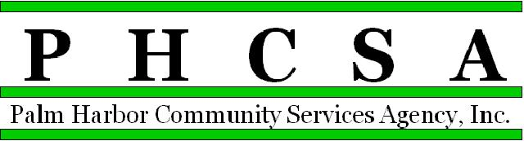
Board Meeting Agenda - 7:00 PM April 20, 2022
Meeting Location: CSA Palm Harbor

1. Opening by Phil Phillips, Chair Call to Order; Roll Call, Pledge

2. Meeting Notice Confirmation

3. Approval of Minutes – March Exhibit

4. Public Comment/Presentations

5. Treasurer’s Report – Phil Wagner
a. Financial Statements and Audit Report Exhibit
b. Audit Results Exhibit

6. Agency Items
a. Old Business
a.
b. New Business
a. Jayme Wilcox - emails
c. Committee reports
a. Managing Director Research Committee
b. Marketing Committee

7. East Lake Recreation
a. Monthly Financial for March - Approval Exhibit
b. Director’s Report - Approval Exhibit
c. Old Business:
d. New Business: East Lake Recreation Parking Expansion Design Contract!!

8. CSA Palm Harbor Parks and Recreation
a. Monthly Financial for March - Approval Exhibit
b. Director’s Report - Approval Exhibit
c. Old Business: Update on Eagle Scout Project update
d. New Business:

9. East Lake Community Library
- Monthly Financial for March - Approval Exhibit
- Director’s Report - Approval Exhibit
- Old Business:
- New Business:

10. Palm Harbor Library
a. Monthly Financial for March - Approval Exhibit
b. Director’s Reports - Approval Exhibit
c. Old Business:
d. New Business:

11. Designation of Next Meeting: May 18, 2022, 7:00 p.m., at East Lake Library

12. Adjournment

